21BDS0340

Abhinav Dinesh Srivatsa

Database Management Systems

Exercise – I

**Tables and Alterations:**

create table employee(f_name varchar(25), m_name varchar(1), l_name varchar(25), ssn number(9), bday Date, address varchar(50), sex varchar(1), salary number(6), super_ssn number(9), dept number(1));

create table department(name varchar(25), num number(2), mgr_ssn number(9), mgr_start_date Date);

create table project(name varchar(2), num number(4), location varchar(25), dept number(2));

**Exercises:**

1. Insert the data given above in both employee, department, and project tables.

Commands:

insert into employee (f_name, m_name, l_name, ssn, bday, address, sex, salary, super_ssn, dept) values('Joyce', 'Y', 'Pan', 543216789, '07-Feb-78', '35 A 18 E, Salt lake City, UT', 'F', 70000, NULL, 2);

insert into department (name, num, mgr_ssn, mgr_start_date) values ('Manufacture', 1, 888665555, '19-Jun-71');

insert into project (name, num, location, dept) values ('A', 3388, 'Houston', 1);

Output:



1. Display all the employees information.

Command:

select * from employee;

Output:

1. Display the employee name along with their SSN and supervisor SSN.

Command:

select f_name, m_name, l_name, ssn, super_ssn from employee;

1. Display the employee names whose birthday is 29-MAR-1959. ‘’

Command:

select f_name, m_name, l_name from employee where bday='29-MAR-1959';

Output:

1. Display the salary of the employees without duplication.

Command:

select distinct salary from employee;

Output:

1. Display the manager SSN, manager start date of the finance department.

Command:

select mgr_ssn, mgr_start_date from department where name='Finance';

Output:



1. Modify the department number of an employee having first name as Joyce to 5.

Command:

update employee set dept=5 where f_name='Joyce';

Output:

1. Alter the department table to add a column for department phone number of number data type and insert values into this column only.

Command:

alter table department add dept_phone_num number(10);

update department set dept_phone_num=1234567890 where num=1;

update department set dept_phone_num=0987654321 where num=2;

update department set dept_phone_num=1236540987 where num=3;

update department set dept_phone_num=0985673214 where num=4;

update department set dept_phone_num=4125012356 where num=5;

Output:

1. Alter the department table and change the department phone number size.

Command:

alter table department modify dept_phone_num number(15);

Output:

1. Modify the field name of department phone number to PhNo.

Command:

alter table department rename column dept_phone_num to PhNo;

Output:

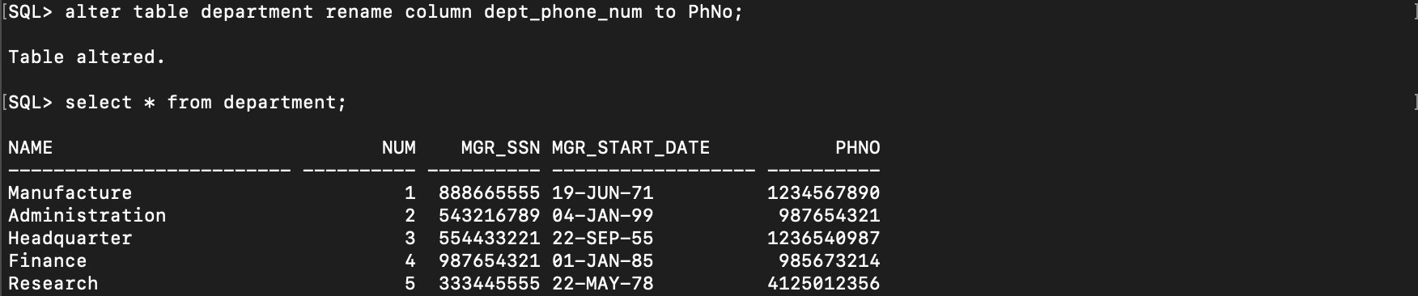

1. Rename the table department to dept.

Command:

rename department to dept;

Output:

1. Alter table dept to remove the column PhNo.

Command:

alter table dept drop column PhNo;

Output:

1. Create table copyofdept as a copy of dept.

Command:

create table copyofdept as (select * from dept);

Output:

1. Delete all the rows from copyofdept.

Command:

delete from copyofdept;

Output:

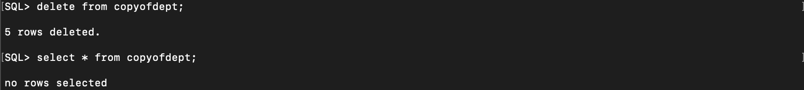

1. Remove the copyofdept table.

Command:

drop table copyofdebt;

Exercise – II

**Tables and Alterations**:

create table employee_bds0340( f_name varchar(25) not null, m_name varchar(1), l_name varchar(25) not null, ssn number(9) not null primary key, bday Date, address varchar(50), sex varchar(1) check (sex in ('M', 'F', 'm', 'f')), salary number(6) default 800, super_ssn number(9), dept number(1), constraint emp_sup_ssn_fk foreign key (super_ssn) references employee_bds0340 (ssn) on delete set null, constraint dept_fk foreign key (dept) references department_bds0340 (num) on delete cascade );

create table department_bds0340( name varchar(25) not null, num number(2) primary key, mgr_ssn number(9), mgr_start_date Date );

alter table department_bds0340 add constraint mgr_ssn_fk foreign key (mgr_ssn) references employee_bds0340 (ssn);

create table project_bds0340( name varchar(2) not null, num number(4) primary key, location varchar(25), dept number(2), constraints dept_fk foreign key (dept) references department_bds0340 (num) on delete set null );

create table dept_location_bds0340( dept_num number(4), dept_loc varchar(15), constraint d_fk foreign key (dept_num) references department_bds0340 (num) on delete cascade );

create table works_on_bds0340( emp_ssn number(9), proj_num number(4), hours decimal(3,1) not null, constraint emp_ssn_fk foreign key (emp_ssn) references employee_bds0340 (ssn) on delete cascade, constraint proj_num_fk foreign key (proj_num) references project_bds0340 (num) on delete cascade );

create table dependent_bds0340( emp_ssn number(9), name varchar(15), sex varchar(1) check (sex in ('M', 'F', 'm', 'f')), bday Date, relationship varchar(8) );

**Exercises:**

1. Insert (‘Robert’, ‘F’, ‘Scott’, ‘943775543’, ’21-JUN-42’, ‘2365 Newcastle Rd, Bellaire, TX’, M, 58000, ‘888665555’, 1) into employee.

Command:

insert into employee_bds0340 (f_name, m_name, l_name, ssn, bday, address, sex, salary, super_ssn, dept) values('Robert', 'F', 'Scott', 943775543, '15513', '2365 Newcastle Rd, Bellaire, TX', 'M', 58000, 888665555, 1);

Output:

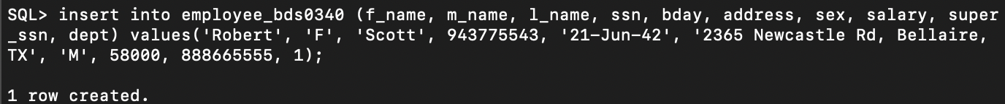

1. Insert (‘677678989’, null, ’40.0’) into works_on.

Command:

insert into works_on_bds0340 (emp_ssn, proj_num, hours) values (677678989, null, 40);

Output:

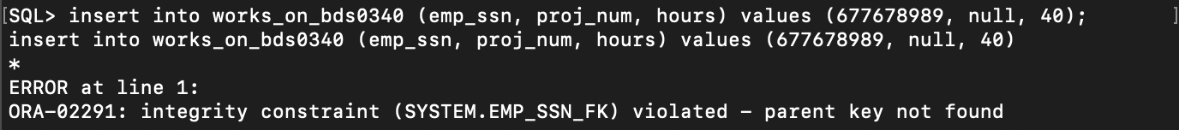

The employee ssn does not exist in the table employee_bds0340.

1. Insert (‘453453453’, ‘John’, ‘M’, ’12-Dec-60’, ‘Spouse’) into dependent.

Command:

insert into dependent_bds0340 (emp_ssn, name, sex, bday, relationship) values (453453453, 'John', 'M', '12-Dec-60', 'Spouse');

Output:



1. Delete the works_on tuples with emp_ssn = 333445555

Command:

delete from works_on_bds0340 where emp_ssn=333445555;

Output:



1. Modify the mgr_ssn and mgr_start_date of the department table with dept_num=5 to 123456789 and ’01-Oct-88’ respectively.

Command:

update department_bds0340 set mgr_ssn=123456789, mgr_start_date='01-Oct-88' where num=5;

Output:



**Alter the tables to:**

1. Add foreign keys using alter table (already done).
2. Drop foreign key defined on super_ssn and add it using alter table command.

Commands:

alter table employee_bds0340 drop constraint emp_sup_ssn_fk;

alter table employee_bds0340 add constraint emp_sup_ssn_fk foreign key (super_ssn) references employee_bds0340 (ssn) on delete set null;

Output:

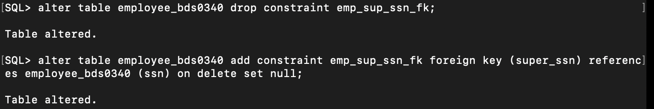

1. Make name of project as unique and sex of employee as not null.

Commands:

alter table project_bds0340 modify (name unique);

alter table employee_bds0340 modify (sex not null);

Output:

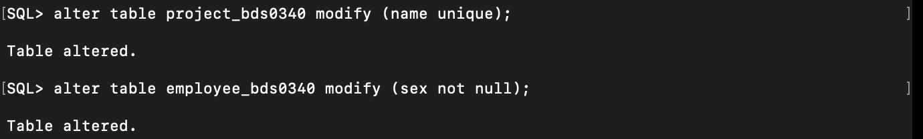

1. Make address as a new type containing door number street, city, state, country.

Command:

alter table employee_bds0340 drop column address;

alter table employee_bds0340 add (door_no varchar(10), street varchar(15), city varchar(20), state varchar(50), country varchar(50));

Output:





1. Make salary of employee to accept real values.

Command

alter table employee_bds0340 modify (salary float(63));

Output:

